Nov 23, 2016

Ben Curet

Supervisor, 9647

Courtenay, BC

Dear Manager,

The attached report describes the poor communication that has worked its way among our staff throughout chain. I expect you will find the gathering of information both sobering and informative, and with proper training and re-evaluation of this situation we can catch and solve this problem in early stages of its development.

The study was based around these four issues:

1. The lost profits based around losing customers to lack of communication.
2. The quality and thought behind getting the information across to members of your team.
3. With continuation of our current trend our sales will continue to decline.
4. The system that is currently in place, to ensure proper efforts are made to communicate information needs to be re-evaluated.

Research consisted of analyzing the problem areas that were resultants of our situation. Secondary research was gathered from surveys conducted throughout the chain.

As a solution to the problems at hand I present 4 different options that will create a solution to the poor communication skills that a large majority of the staff carry.

1. Computer Based training
2. Tri-Yearly Communication Refresher
3. Weekend Communication Bootcamp
4. New Designated Place for Communication

I would be pleased to discuss this report and its options with you at your request. I appreciate your time and hope to meet with you in the future.

Sincerely,

Ben Curet Supervisor

|  |  |
| --- | --- |
| v.1 | COMMUNICATION PROPOSAL  Prepared for Manager • Nov 23, 2016  Prepared by Ben Curet |

# Project Proposal

|  |  |
| --- | --- |
| v.1 | 1.0 Issue for analysis…………………………………………………………………………… 3  2.0 Background………………………………………………………………………………… 3  3.0 Introduction……………………………………………………………………………….… 3  3.1 Option 1……………………………………………………………………………. 4  3.2 Option 2……………………………………………………………………………. 4  3.3 Option 3…………………………………...........................................................5  3.4 Option 4……………………………………………………………………………..5  4.0 Schedule……………………………………………………………………………………..5  5.0 Variables……………………………………………………………………………………..6  6.0 Budget………………………………………………………………………………………..6    7.1 Computer based training………………………………………………………….6  7.2 Tri-Yearly Communication Refresher…………………………………………….7  7.3 Weekend Communication Bootcamp……………………………………………8  7.4 New Designated Place for Communication……………………………………..8  8.0 Current situation……………………………………………………………………………..9  9.0 Recommendation and Conclusion………………………………………………………...9  10.0 Authorization……………………………………………………………………………….10  11.0 Appendix…………………………………………………………………………………….11  11.1 Communication or Communications (8.1 Computer based training)............11  11.2 Management Communicates frequently employees-agree (8.2) …………..12  …………………...Tri-Yearly Communication Refresher  **A** |
|  |  |

**1.0 Issue for analysis**

Staff have been creating problems that are very much avoidable with simple actions that they are not following, such as not communicating important information among~~st~~ each other. The problems are either not being noticed by the managers of each department or the staff’s actions are not realized as a problem. It’s natural to think trends such as communication start at the top. While I expect communication to be led at the top, it’s important to understand it actually starts with every one of us. The current system is either not defined enough or the staff are not taking time to abide by the rules. If we either have to take punitive actions or retrain staff, there needs to be proper actions taken to maintain our reputation~~s~~ that is slowly slipping away. The lost profit we have been experiencing can be stopped with proper training across the chain to bring information, quality and assurance to our customers.

**2.0 Background**

Over the course of almost 60 years~~,~~ we’ve built a legacy of consistently setting the bar high and creating unique food trends in the markets we serve. This has led to us standing out against our competitors and driving sales in our stores. Providing a consistent experience at our stores will keep customers coming back and help grow those all-important sales. While we can’t control what our competitors do, we can control some key things to create an in-store experience that makes it easy for customers to decide to shop with us again. One of the most important factors that will be focused on throughout this report is communication. The communication competence of a ~~‘~~staff member~~’~~ is the best evaluation of their importance as an employee (Modlock 2008, 36). The standing situation that we are in has derived from bad habits that has seemed to circulate through one another and brought us to where we are today. Before forwarding a proposal to head office for review I request your authorization to do so. If you have not noticed already it seems as if the newly occurring problem of poor communication seems to emanate from our diverted attention to our new program around product quality.

**3.0 Introduction**

Communication amongst the store has been consequently poor in the store in the past few months and is just getting worse. Staff have been failing to communicate progress on projects, order information, ideas, and have been communicating on a non-need to know basis which has gotten out of hand and has led to many unacceptable outcomes. I present four options to fix this issue, a new electronic computer based training program, a weekend communication boot camp hosted by a company specified in this field, or a new designated communication area. I do not mean to put down our new program, but there needs to be a balance between our focus so it can be harmonized to create a great customer experience as we are all hopefully aiming for. Good communication skills pave a path for further advancement in most places of work and create a strong bond with team members (McIntosh, Perry et al 2008, 10). As the company expands and we have many new hires ~~and~~ it is easy to have staff led in the wrong direction. In my experience I remember starting here decades ago and being molded as an individual where there were stepping stones provided by my superiors in the workplace. A widespread misconception throughout the company is that there are too many employees assuming that they doing everything in their power to communicate information to their coworkers. This delusion is where the problem starts. We as a company we need to go back to the basics to regain our roots. Here are some possible solutions to our problem.

**3.1 Option 1**

**Computer Based training**

An initial start-up of this option would be very costly but a very effective long term option that is standardized and self-sustained, ensuring that the our training across the chain is consistent making for a seamless transfer. I understand that this option lacks a face to face human communication. Any new staff that went through this program lacks the relationship building time with any coworkers if they were to be trained by perhaps a supervisor~~'s~~.

**3.2 Option 2**

**Tri-Yearly Communication Refresher**

The most wage cost intensive option presented would be the tri-yearly communication refresher option. An interactive five hour long course involving groups of ten people at a time, ranging between new staff and managers, which occurs every four months. It creates an open environment where ideas are shared for possible better solutions to communication problems and old systems are restated. These meeting could give opportunities for building better relationships with the different levels of positions as well as coworkers that might not work in the same department. Where relationships are built it is then less of a strain and becomes more natural to communicate information.

**3.3**  **Option 3**

**Weekend Communication Boot-camp**

A quick acting turn around where the staff members are sent to a local company that specializes in a communication workshop. Social-communication skills are critical to~~,~~ social success, and long-term quality of life outcomes, such as social inclusion, interpersonal relationships, and self-determination (Keith, Verdugo, & Gomez 2011, 14). Although a costly program no wage cost will be put towards training our staff members to be the ones teaching. The downside to this option would be that staff would have to be re-submitted through the program later in the year to be refreshed as well as any new staff who join~~ed~~ our team. In the long run this program would be costly.

**3.4 Option 4**

**New Designated Place for Communication**

Every staff member would be required to start off the day by going to the communication room/area and read the new documents, plan for the day, orders that need to filled or anything new that has been implemented; as well as complete the communication quiz of the day regarding what they read and sign off on the sheet. This option would be the least expensive option and a very simplistic approach to a big problem. Creating a sheet that only had to be reviewed once by the manager when it was created could be time effective compared to having all the information communicated verbally involving two bodies.

**4.0 Schedule**

With your approval, I have arranged a schedule to begin our program development and have it in place by one month from today. Regardless of the final program option chosen, every current employee will be run through the program and be up to date with the new system two months from now, as well as any new co-workers joining our team.

**5.0**  **Variables**

|  |  |
| --- | --- |
| n | Wage for specific person |
| X | Number of employees |

**6.0 Budget**

**7.1** **Computer Based training**

|  |  |  |  |
| --- | --- | --- | --- |
|  | **Estimated Hours** | **Rate** | **Total Yearly** |
| Program Development | 1000 | $43.00 | $43000 |
| Program Installation | 5 | $30.00 | $150.00 |
| Employee Wage for Training | X(5 hours) | R | R(5X) |

|  |  |
| --- | --- |
| **Disadvantages** | **Advantages** |
| Lack of face to face teaching | Ensuring chain wide standardized training |
| Initial start up cost | Long term cost effective |

**7.2** **Tri-Yearly Communication Refresher**

|  |  |  |  |
| --- | --- | --- | --- |
|  | **Estimated Hours** | **Rate** | **Total Yearly** |
| Creation of Boot camp Team ( 8 people) | 50 | n1X+n2X... | Approx $8000 per store |
| Employee Wage for Training | 5 | n1X+n2X... | Approx $2000 per store |

|  |  |
| --- | --- |
| **Disadvantages** | **Advantages** |
| Team has to be retrained as well as the staff being trained. | A team trained specifically for this situation would be prepared and remain available to go around each store and bring every employee up to speed on communication. |
|  | Face to face interaction would be very effective to create ~~a~~ good habits. |

**7.3 Weekend Communication Bootcamp**

|  |  |  |  |
| --- | --- | --- | --- |
|  | **Estimated Hours** | **Rate** | **Total Yearly** |
| Travel cost | N/A | n1X+n2X... | Approx $1200 per store |
| Employee Wage for Training | 5 | n1X+n2X... | Approx $2000 per store |

|  |  |
| --- | --- |
| **Disadvantages** | **Advantages** |
| Travel cost | A team trained specially for this situation would be prepared and remain available to go around each store and bring every employee up to speed on communication. |
| New staff ~~would~~ wouldn’t be up to date until they were sent through the program | Face to face interaction would be very effective to create ~~a~~ good habits. |

**7.4 New Designated Place for Communication**

|  |  |  |  |
| --- | --- | --- | --- |
|  | **Estimated Hours** | **Rate** | **Total Yearly** |
| Equipment | N/A | $100 | Approx $100 per store |

|  |  |
| --- | --- |
| **Disadvantages** | **Advantages** |
| More work for the manager | Signatures and quiz marks would prove that the staff are up to date or not. |
|  | Reading the documents would be time effective only involving one person to take the information in. |

**8.0 Current situation**

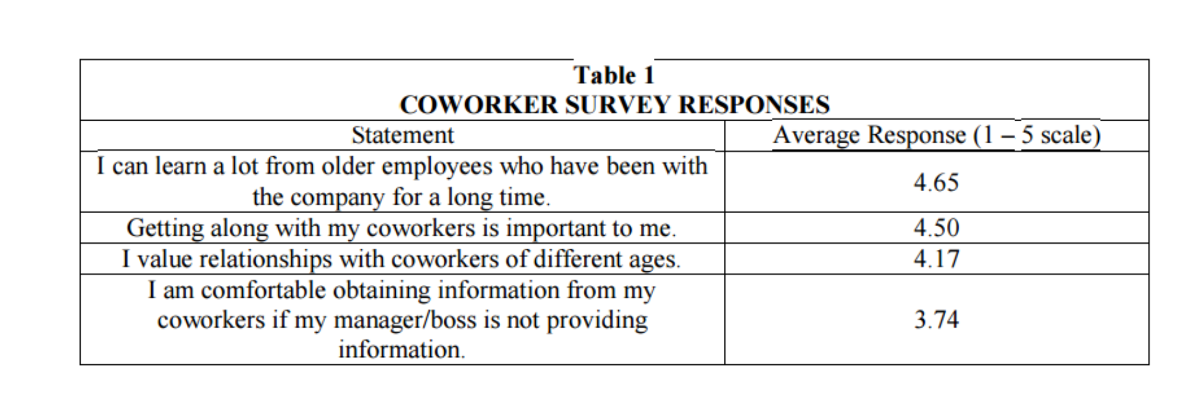

To aid in your decision in selecting an option(s) this survey has been provided based off of the employee’s feedback. Now that we are update on the problem we can begin to make a plan of action to gain control of our situation. Based off the information from the employee surveys we can create an effective program.

**9.0 Recommendation and Conclusion**

Where the situation stands at the moment, a hybrid of ideas would be a consideration to lean towards in order to kick-start the company in the right direction. Ideally, a combination of all of the options would help and sustain the company the most, although keeping cost in mind, I have two that would suit us. A combination of a new designated place for communication and Tri-Yearly Communication refresher would not only start the company on the right path, but ensure information is kept up to date with the staff. It would also give the staff a chance to share opinions and build a strong relationship with each other through the meetings.

**10.0 Authorization**

If pleased with the offer, please sign the enclosed duplicate copy of this letter and forward it to head office so they can begin the process.

xx____________________________

Sincerely,

Ben Curet , Department Supervisor

**11.0 Appendix**

**11.1 Tri-Yearly Communication Refresher (7.1) heading**

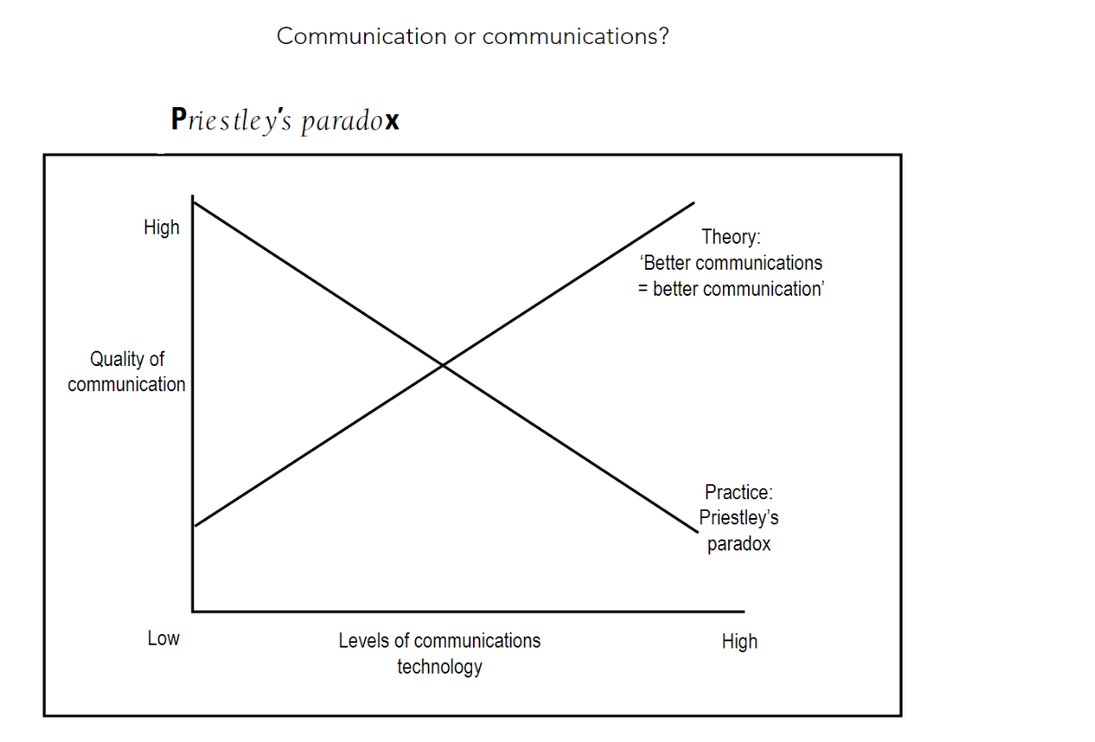

**11.2 Tri-Yearly Communication Refresher (7.2) heading**

Management Communicates Frequently with Employees-Agree Responses

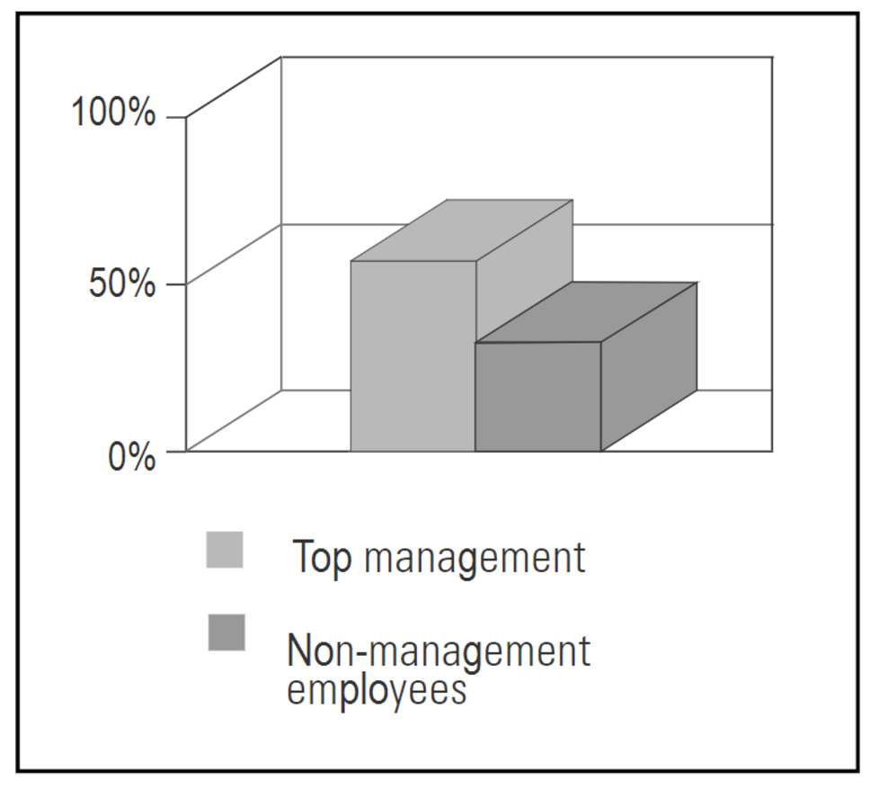

**References**

1.Ashley Hall and Stephen F, "*Exploring The Workplace Communications Preferences of Millennials* ," 121,Volume 20 no. 1 (2016): 44, accessed October 15, 2016.

2. Joann Keyton et al., " *Investigating Verbal Workplace Communication Behaviors* ," 121,Volume 20 no. 1 (2013): 44, accessed October 18, 2016.

3. Euson, Barden " *Communication in the Workplace Wiley Business tool series* ," Milton Qld, (2007), accessed October 18, 2016.

4. Crista Mohammed., " *Communicating in the Workplace : Self-Reports by NEW UWI Electrical and Computer Engineering Graduates* ," 93, Vol 38 no. 2 (January 2016), accessed October 19, 2016.

5.Kyle E. Briank,Robert D. Costigan., " *Oral Communication Skills: Are the Priorities of the Workplace and AACSB Accredited Business Programs Aligned?* ," 121,Volume 14 no. 2 (2015), accessed October 18, 2016.

6.McIntosh, Perry, et al. Interpersonal Communication Skills In The Workplace. [New York?]: AMA Self-Study, 2008. eBook Academic Collection (EBSCOhost). Web. 18 Nov. 2016.

.

7. Hedda Meadan et all., “Internet-Based Parent-Implemented Intervention for Young Children With Autism: A Pilot Study”, 38(i) 3-23 vol 38 ( 2016) accesed Nov 19, 2016

8. Özdemir, Muzaffer “The Analysis of the Relationship between Primary Learning Styles and Learning Objects in an Online Environment”, v15 n1 p34-50 2016. 17 pp. Accesed Nov 23, 2016

Overall the content was well put-together and it was a professional report. There was a few grammar and punctuation problems which I have either corrected in red, or put a strike-through in red where a word was unnecessary or incorrect. The only thing I would highly suggest being cautious with is run-on sentences. There may be some issues with your references that you may want to look over, such as the spelling of “accessed”, etc. Overall, if I was a manager I would definitely take your issue seriously. Thank you!